Herbivory and competition in endangered mountain yellow-legged frog tadpoles

Thomas C. Smith†, Marina Bozinovic, Yishen Miao, Cherie J. Briggs

Department of Ecology, Evolution, and Marine Biology, University of California, Santa Barbara, California 93106 USA; phone: (805) 893-2888

†email: thomas.smith@lifesci.ucsb.edu

Abstract:

Worldwide declines of amphibian populations and loss of amphibian biodiversity have prompted investigations into the ecological functions of endangered and declining amphibian species. In the Sierra Nevada of California, mountain yellow-legged frogs are nearly extinct, yet we have little explicit knowledge of their ecological interactions, especially for the grazing tadpoles. We performed two experiments to quantify the extent to which tadpole grazing can control abundance of benthic material, and to quantify to the extent to which tadpoles competed with another abundant grazer, mayflies (Ephemeroptera). In field enclosures in two remote high elevation lakes, we manipulated the densities of tadpoles and mayfly nymphs in a response surface design, and measured the abundance of benthic algae biweekly. We found negative effects of tadpoles and mayflies on algal abundance, but no evidence of intra- or interspecific effects on the sizes of or biomass of either consumer. To test the effects of consumers on algae, independent of potential effects of the lake, we performed mesocosms experiments in which we manipulated the presence and absence of high densities of tadpoles and mayflies. Tadpole presence alone had a negative effect on algal abundance and growth. Taken together, these two results suggest that the absence of endangered mountain yellow-legged frog tadpoles allows benthic producers to reach higher abundance and biomass. In lakes relative to mesocosms, this effect seems to be weakened or obscured by the within lake variability in algal abundance that may result from environmental heterogeneity found in natural lakes.

1. Introduction
   1. Amphibian declines
   2. Mountain yellow-legged frog declines
   3. Tadpoles as grazers and competitors
   4. Potential effects of tadpole loss
   5. Predictions/hypotheses:
      1. Abundance of algae lower in presence of tadpoles, and more so with higher densities of tadpoles
      2. In field enclosures: both consumers exhibit both intra and interspecific competition
         1. Tadpoles are smaller or slower growing at high densities
         2. Mayflies are smaller or slower growing/less emergent at high densities
         3. Mayflies are smaller or less emergenent in presence and at high densities of tadpoles.
      3. In Mesocosms, presence of tadpoles reduces algal abundance/growth
         1. Tadpoles reduce algae
         2. Mayflies reduce algae
         3. Tadpoles and mayflies each smaller when together
   6. Objective:
      1. To quantify the effect of MYLF tadpoles on resources and a potential competitor

Methods

We performed two experiments, a field experiment and a mesocosm experiment. Our field experiment allowed us to describe, within the natural setting of two remote high elevation lakes, the interactions between two consumers: tadpoles (*Rana muscosa* and *Rana sierrae*) and mayfly nymphs (Ephemeroptera, *Callibaetis ferrugineus* and *Ameletus spp.*), and their shared resource, benthic organic matter which consists largely of diatoms (hereafter, algae). In the mesocosm experiment, we tested the effects of the same grazer in artificial habitats which controlled for natural nutrient, temperature, substrate heterogeneity found within most lakes.

In the field enclosure experiment, we use a response surface design () to characterize the independent and interactive effects of grazers. Response surface designs facilitate description of intra- and interspecific interactions, as they allow two factors to vary alone and together. For each of our two consumers, we established four treatment levels, including the absence of and three density levels of each, the highest of which was set by the highest densities of these two consumers we have observed in other surveys (Roland A. Knapp, unpublished data, and Smith et al., in review). Tadpole treatment levels were 0, 2, 10, and 20 individuals, while mayfly treatment levels were 0, 25, 125, and 250 individual mayflies. Each treatment was a pairwise cross of two of these treatment levels, and was replicated once in each of two lakes, except the zero-tadpole/zero-mayfly treatment which was replicated twice in each lake (total n = 34).

The two study lakes were remote high elevation lakes in the King’s Canyon National Park backcountry, referred to as LeConte (3221 m elevation, 37°06'58.78" N 118°38'40.16" W) and Spur (48 km to the southeast of LeConte, 3518 m elevation, 36°43'47.49" N 118°23'38.33" W, (Google Earth 2014)). Both lakes lie close to and west of the Sierra Nevada crest. They are small alpine lakes, however, while LeConte is surrounded by small meadows, white bark pine and willow, and bare rock, Spur is in a basin devoid of vegetation. The water in these lakes has low nutrient concentrations and circumneutral pH: nitrate 0 – 10 μmol L-1, total phosphorus 0 – 1 μmol L-1 (Sickman et al. 2003); median pH ≅ 7 (Bradford et al. 1998). We selected these two lakes because both had large, disease free cohorts of mountain yellow-legged frog tadpoles (R.A. Knapp, personal communication), were relatively accessible, and not in areas frequently used by backpackers.

The 17 enclosures in each lake were placed along the shoreline in the littoral zone, where tadpoles and mayflies feed during the day. Enclosures were 0.5 m wide x 0.5 m tall at one end and 0.5 m wide and 1.5 m tall at the opposite end, and were 2 m long (1 m2 on the bottom). Each was oriented perpendicular to the shoreline, so that the tall end sat in deep water, and the short end sat along the shoreline (Fig. 1). An above-water space was left in the top of each enclosure to accommodate emerging mayflies, and one clean rock was placed inside each enclosure to accommodate metamorphosing tadpoles. Enclosures were supported by a light weight steel frame and guy-lines, and were constructed from Nitex (citation?) and organza fabric, with mesh size of approximately 250 μm. This mesh size prevented escape of mayflies and tadpoles, and prevented invasion by other benthic macroinvertebrates, but allowed movement of sediment, phytoplankton, and small zooplankton (mostly Copepoda).

We captured tadpoles and mayflies in each lake. We captured tadpoles throughout both lakes and after weighing and staging them (Gosner 1960), included those between Gosner stage 26 and 41. In LeConte, tadpoles were *Rana sierrae*; in Spur tadpoles were *Rana muscosa* (Vredenburg et al. 2007). We captured mayflies in the littoral zone of the lakes using benthic sweeps of a standard D-net (mesh size 250 μm), and separated mayflies from other invertebrates in a sorting pan using flexible forceps and a turkey baster. While mayflies were not chosen based on instar, when possible those with wingpads were not included. In LeConte, mayflies were virtually all *Ameletus spp.*, but in Spur, *Ameletus spp.* and *Callibaetis ferrugineus* were present in equal proportions. Algal growth was measured from porcelain tiles placed on the bottom of each enclosure (two sets of 12 porcelain tiles, each 2.4 cm x 2.4 cm, 140 cm2 total area per enclosure). We established a no-consumer pseudo-control for each enclosure by placing a set of tiles in a small bag made of the same mesh as enclosures, and setting it in the littoral zone next to each enclosure. This provided a way to account for within lake heterogeneity in algal growth. To account for potential differences in algal communities and light availability within each cage, we recorded substrate type and insolation within each cage. Substrate was described as percent of the substrate below each enclosure which was composed of silt (defined as particles < 0.5mm); the percent of substrate composed of silt has been found to be a predictor of community composition in Sierra Nevada lakes (Smith et al. n.d. in review, Knapp and Matthews 2001). Photosynthetic photon flux (solar radiation) was measured within each enclosure at the water surface using a basic quantum meter (Apogee Instruments, Logan, UT).

Experiments began in the early ice-free season (17 July 2009 in LeConte and 21 July 2009 in Spur), and ran in three blocks. Enclosures were sampled every two to three weeks. We collected algae samples from enclosure tiles and from pseudo-control tiles, for later determination of ash-free dry mass (AFDM). At the conclusion of each block, we counted, weighed, and staged tadpoles. We counted mayfly nymphs, and counted and collected emerged adult mayflies. We maintained the densities of these two consumers, despite development and metamorphosis requiring the removal of individuals from enclosures. When tadpoles were older than stage 38 at one visit, they were removed to prevent metamorphosis prior to the next visit; each removed individual was replaced with a younger tadpole. Similarly, adult mayflies which emerged from the nymph stage were replaced by younger individuals. At the conclusion of the entire experiment, all tadpoles were weighed and staged a final time, and released back into the lakes. We collected and preserved all mayfly nymphs from enclosures, and measured them to the nearest 0.1 mm under 10 x magnification.

In order to calculate a length-mass regression relationship for mayflies, we also collected a separate sample of mayflies from each lake. These mayfly nymphs were dried at 105 C for 24 hours, weighed, combusted at 500 C for 1 hour, and weighed again; ash free dry mass was calculated as the difference between the two weights. In order to calculate a Gosner stage-mass regression for tadpoles, we collected, euthanized and preserved in 10% formalin 37 tadpoles from Marmot Lake (3590 m elevation, 37°15'36.33" N 118°41'01.38" W). Ash free dry mass was calculated as it was for mayflies.

Algae abundance was calculated for each enclosure on each sampling date. In the field, algae was scrubbed from tiles using a soft-bristle toothbrush, and suspended in 60 mL of water. Suspended algae were collected on a glass fiber filter with 1.2 μm pore size, using a hand powered vacuum pump. Filters were stored in a cool dark place (under a boulder) in field until they could be frozen in the lab for later processing. Filters were dried at 105 C for at least 24 hours, weighed, combusted at 500 C for 1 hour, then weighed again. Ash-free dry mass was calculated as the difference between filter weights before and after combustion (Hauer and Lamberti 2007). When less than 60 mL of suspension were filtered, we multiplied the AFDM by the fraction of 60 mL that was filtered.

* 1. Field Enclosures (aka “Field”)
     1. Design: response surface, nestedness, blocking, sampling dates
     2. Setting
     3. Enclosures
     4. Animal collections
     5. Sample collection: Algae for AFDM
     6. “Controls”: no consumer ‘bags’ sampled each week also
     7. Other collections
        1. Tadpole wet weights, gosner stage, “emergence”,
           1. Vs. wild tadpoles
        2. Mayfly emergence, identity
           1. Vs. wild mayflies

We also conducted a mesocosm experiment to further explore the effects of tadpoles and mayflies on algal resources, without the environmental variability that occurs throughout lakes. We used a factorial design, with treatment levels for presence and absence of tadpoles and mayflies, arranged randomly among four blocks (n = 16); there were four replicates of the four treatments no consumers, tadpoles only, mayflies only, and tadpoles and mayflies. Four mesocosms contained zero consumers, four contained16 tadpoles, four contained 250 mayflies, and the remaining four contained 16 tadpoles and 250 mayflies.

Mesocosms were located at the Sierra Nevada Aquatic Research Laboratory near Mammoth Lakes, CA (2165 m elevation, 37°36'50.83" N 118°49'57.56" W). We used sixteen cube shaped (1 m x 1 m x 1 m) concrete tanks lined with Thoroseal concrete sealer, with sloping shelves on the south facing side to allow tadpoles and metamorphs to bask (Fig.1). These tanks were filled with water from adjacent Convict Creek; nitrate and phosphate levels in Convict Creek are similar to those observed in most Sierra Nevada lakes (and presumably our two study lakes) however pH is higher than most Sierra Nevada lakes (pH 7.9 – 8.5) (LELAND et al. 1989, Bradford et al. 1998, Sickman et al. 2003). Creek water was the source for algae, and mesocosms were filled in April 2010 to allow algae communities to develop prior to the introduction of consumers. Each mesocosm contained thirty sets of twelve porcelain tiles (similar to those used in the field enclosures, each tile was 2.4 cm x 2.4 cm, total area of 12 tiles x 30 sets of tiles: 2074 cm2) to provide standard surfaces on which we could measure algal abundance; twenty five were placed on the bottom of each mesocosm, and five were placed on each shelf.

We collected 160 *Rana sierrae* tadpoles (Gosner stages 34-39) from Marmot Lake (3590 m elevation, 37°15'36.33" N 118°41'01.38" W) and transported them in one gallon containers with portable aerators and packed in snow. About 3000 mayflies (*Callibaetis ferrugineus*) were collected from a small pond in Yosemite National Park (2608 m elevation, 37°53'07.18" N 119°23'39.97" W) using a D-net with 250 μm mesh size, sorted them using 250 μm sieves, pipettes, and turkey basters, and transported them similarly to tadpoles.

The experiment began in late July 2010 when we added consumers to the mesocosms. We were not able to maintain the mayfly densities, because mayflies were surprisingly difficult to detect in the mesocosms, and apparently experienced high mortality (48% to 100%). Tadpole density was maintained by adding younger tadpoles to replace individuals which metamorphosed and were removed. We ended the experiment when so many tadpoles metamorphosed that we could no longer maintain tadpole densities in the mesocosms. All remaining tiles were then sampled.

In the mesocosm experiment, we sampled algal abundance three times in August. On each date, we sampled bottom tiles and shelf tiles. Tiles on the bottoms of mesocosms were exposed to grazing for one, two, and three weeks; on the first sample date 15 tiles were removed from mesocosms, sampled for algae and replaced, on the second date, 5 previously sampled tiles were removed, sampled again, and replaced, then on the third date all remaining tiles were removed and sampled. Four out of five tiles on the shelves were sampled each week and replaced; the fifth was sampled only at the end of the experiment. For all tiles, we scrubbed algae from each tile, suspended it in 60 mL of water, and filtered the suspension onto a glass fiber filter, as described above. These samples were frozen immediately, and later processed for AFDM as described above. When less than 60 mL of suspension were filtered, we multiplied the AFDM by the fraction of 60 mL that was filtered. At the conclusion of the experiment, we measured size (body length not including tail length) and developmental stage (Gosner stage) of at least 10 tadpoles from each mesocosm. We sampled each mesocosm for mayflies using the same D-net used to collect them, until 10 back to back sweeps collected no more mayfly nymphs. Mayflies were counted, but not measured.

* 1. Mesocosms (aka “Mesocosm”)
     1. Blocking, randomization, sampling dates
     2. Animal collections/transportation
     3. Mayfly issue
     4. Sample collection: Algae for AFDM
     5. Other collections
        1. Tadpole
  2. Lab Processing
     1. AFDM of algae
     2. Tadpole, mayfly AFDM
  3. Analytical Methods
     1. Summary statistics –
        1. datasets separated by lake?
        2. Temporal patterns – or averaged over times?

*Analytical methods. –* For our analysis of field enclosure data, we used two sets of independent variables in alternative analyses. In one, the two independent variables were the categorical variables mayfly density and tadpole density, with four levels for each density treatment of each consumer. We also included a categorical covariate for lake, with two levels (LeConte and Spur). This covariate accounted for differences between lakes such as elevation, temperature, or size. We also included continuous covariates for days between samples, solar radiation within enclosures, and substrates beneath enclosures.

Alternatively, instead of using the categorical variables for mayfly and tadpole density, we used total ash free dry mass weights estimated for each consumer within each enclosure. For mayflies, per-enclosure AFDM was estimated based on the average mayfly mass calculated from a length-mass regression relationship and the number of mayflies counted in each enclosure. We used the length-mass relationship to calculate the total estimated AFDM for mayflies in each enclosure based on the lengths of the individuals we had measured. For tadpoles, we used the Gosner stage-mass relationship to estimate the total AFDM for tadpoles from each enclosure, based on the Gosner stages we observed for each tadpole. These biomasses for each consumer were used as continuous independent variables in our analyses, with the same covariates described above.

Our response variables of interest was, for each enclosure, algal abundance (algae AFDM m-2). We used linear mixed effects models (Zuur et al. 2009) to test the effect of consumer density and consumer biomass on algal abundance, with response variable algal abundance, predictor variables tadpole and mayfly abundance or biomass, and covariates siltiness, radiation, lake, and experimental block. To meet the assumption of normality of residuals (Zuur et al. 2009), we log transformed raw algal abundance. We compared models that included random intercepts (for block and for lake), random slopes for consumer effects in different lakes, and allowed variance to differ among experimental blocks, lakes, and levels of mayfly and tadpole density (Zuur et al. 2009).

To account for within lake variability in algal abundance, we also corrected raw algal abundance by subtracting from it the algal abundance in pseudo-control tiles and repeated analyses. In this analysis, basic transformations did not increase normality of residuals in a simple linear regression model which included the response variable algal abundance, the predictor variables tadpole and mayfly abundance or biomass, and the covariates siltiness, radiation, lake, and experimental block. Therefore…

In our analyses of mesocosm algal abundance, the independent variables were tadpole abundance and final mayfly abundance. We included covariates for tile location (categorical; shelf vs. bottom) and period of algal growth (days). We used… linear models, normality, homogeneity of variance. We included a random effect (intercept) for mesocosm number nested within experimental block.

* + 1. Independent variables
       1. Factors:
          1. F: Mayfly density, Tadpole density, estimated biomasses, change in estimated consumer biomass
          2. M: Tadpole presence/estimated biomass
       2. Covariates: Days of growth/Days in Block, substrates, insolation,
       3. Random:
          1. Field:

lakes (encompasses temperature, elevation, nutrient availability, etc)

date/Sample Number/block

* + - * 1. Mesocosm: block
    1. Dependent variables:
       1. Any of
          1. Algae AFDM,
          2. Algae AFDM/m2,
          3. Algae Growth Rate: change in AFDM between two samples, and Algae Growth Rate per m2.
          4. “Control Difference”: The experimental AGR/m2 subtracted from the “control” AGR/m2
       2. Field also included:
          1. Tadpole size/weight/stage
          2. Mayfly

1. Results
   1. Field

Algal abundance (g AFDM cm-2) was seven times higher in Spur than in LeConte (df = 1,100, F = 12.593, p < 0.0005916).

The best fit linear model (Table 1) of the raw algal abundance used log-transformed raw algal abundance to meet the assumption of normality of model residuals. The model also included tadpole density and mayfly density as continuous variables, and lake as a covariate factor. Inclusion of a random intercept for experimental block allowed mean algal abundance to differ among blocks (Table 2). In this model, algal abundance differed between lakes (Figure 2), and both tadpoles and mayflies had negative effects (Figure 2). The interaction between consumers was not retained as a fixed effect in this best model. We also tested models that allowed the slope of the relationship between each consumer and algal abundance to differ between the two lakes, and an additive model with a non-linear relationship between silt and algal abundance; these models were not better.

The best fit linear mixed effects model of pseudo controlled algal abundance included fixed effects for tadpole density, mayfly density, and siltiness. The model also included random intercepts that allowed the mean controlled algal abundance to differ with respect to experimental block, nested within lake, and allowed variance of controlled algal abundance to differ among experimental blocks and between lakes (Table 3). In this model, tadpole and mayflies both have negative effects on the controlled abundance of algae; silt also had a negative effect on algal abundance (Table 4). The interaction between consumers was not retained in this model.

* + 1. Mayfly
       1. Yishen
    2. Tadpoles
       1. Marina
  1. Mesocosm
     1. Mayfly mortality
     2. Algae abundance/growth

In the 2010 mesocosm experiment, the best-fit model included fixed effects for tadpole and mayfly presence, and for their interaction. Both consumers had negative effects on algal abundance, but the interaction between the two had a positive effect. This model also included a random intercept for tile location, and allowed variances to differ among consumer treatment levels. In the mesocosms, mayflies experienced high mortality or dramatic emergence. Final counts of mayflies indicated that mesocosms lost 48% – 100% of the 250 mayflies which were placed in each mayfly treatment at the start of the experiment. Exuvia or emerged adults were never observed. This apparent mortality was independent of coexistence with tadpoles; despite a trend towards lower final mayfly abundance in the presence of tadpoles, the difference was not significant (ANOVA, df = 6, F = 0.338, p = 0.58). Because these final mayfly densities were so different than the initial densities, we analysed algal abundance in the final sample only using tadpole presence and final mayfly abundance, rather than presence, as independent variables. In this case, the best-fit linear model included fixed effects for tadpole presence and mayfly abundance, but did not include an interaction. This model also included a random intercept allowing mean algal abundance to differ between the basking shelf and the mesocosm bottom, and allowed variance to differ with respect to tadpole presence-absence (Table 6). It is notable that these two models, which differ in how they represent mayfly treatments, contradict one another.

1. Discussion
2. References

Tables

|  |  |  |  |  |
| --- | --- | --- | --- | --- |
| Fixed effects | Response variable transformation | Random effects | Heterogeneity of variances | AIC |
| Tadpole Density x Mayfly Density + Lake +  Days in Block + Silt + Radiation + Block |  |  |  | 452.07 |
| Tadpole Density x Mayfly Density + Lake +  Days in Block + Silt + Radiation + Block | Log transformed |  |  | 327.75 |
| Tadpole Density x Mayfly Density + Lake +  Days in Block + Silt + Radiation | Log transformed | Block |  | 329.5  But residuals more normally distributed |
| Tadpole Density x Mayfly Density +  Days in Block + Silt + Radiation + Block | Log transformed | Lake |  | 334.0 |
| Tadpole Density x Mayfly Density +  Days in Block + Silt + Radiation | Log transformed | Block nested in Lake |  | 335.05 |
| Tadpole Density x Mayfly Density + Lake +  Days in Block + Silt + Radiation | Log transformed | Block | By lake | 300.4  Increases non-normality of residuals |
| Tadpole Density x Mayfly Density + Lake +  Days in Block + Silt + Radiation | Log transformed | Block | By block | 327.5  Increases non-normality of residuals |
| Tadpole Density + Mayfly Density + Lake +  Silt + Radiation | Log transformed | Block |  | 326.8 |
| **Tadpole Density + Mayfly Density + Lake** | **Log transformed** | **Block** |  | **324.9** |

Table 1. Summary of candidate models of raw algal abundance in 2009 field enclosure experiment, using numerical tadpole and mayfly density as the independent variables. The final, best-fit model is in bold face.

|  |  |  |  |  |  |
| --- | --- | --- | --- | --- | --- |
| Predictor Variable | Linear model coefficient | df | t-value | p-value | Random intercept |
| Tadpole Density | -0.03 ± 0.01 | 96 | -1.8 | 0.0824 |  |
| Mayfly Density | -0.002 ± 0.001 | 96 | -1.3 | 0.19 |  |
| Lake | Mean of algal abundance in Spur 1.1 > than LeConte | 96 | 4.6 | <0.0001 |  |
| Block |  |  |  |  | Variance for the random intercepts: 0.02; variance for the residuals : 1.3; correlation between observation within block 0.02 |
|  |  |  |  |  |  |

Table 2. Terms of best-fit model of log transformed raw algal abundance in 2009 field enclosure experiment, using numerical tadpole and mayfly density as independent variables.

|  |  |  |  |
| --- | --- | --- | --- |
| Fixed effects | Random effects | Heterogeneity of variances | AIC |
| Tadpole Density x Mayfly Density + Siltiness + Radiation |  |  | 362.0 |
| Tadpole Density x Mayfly Density + Siltiness + Radiation | Lake, Block |  | 367.1; but reduces correlation between fitted values and residuals, and enhances normality of residuals |
| Tadpole Density x Mayfly Density + Siltiness + Radiation | Lake, Block | Lake, Block | 231.0 |
| **Tadpole Density + Mayfly Density + Siltiness** | **Lake, Block** | **Lake, Block** | **228.9** |

Table 3. Models of controlled algal abundance for 2009 field enclosure experiment, using numerical tadpole and mayfly density as the independent variables.

|  |  |  |  |  |  |  |
| --- | --- | --- | --- | --- | --- | --- |
| Predictor Variable | Linear model coefficient | df | t-value | p-value | Random intercept | Combined Variance functions |
| Tadpole Density | -0.0069 | 92 | -1.8 | 0.08 |  |  |
| Mayfly Density | -0.0011 | 92 | -3.7 | 0.0004 |  |  |
| Proportion of silt in cage substrate | -0.0015 | 92 | -1.7 | 0.10 |  |  |
| Block (nested in lake) |  |  |  |  | Variance for the random intercept: 0.04; variance for the residuals: 0.10; correlation among observations from same block: 0.15, p=??? | Standard deviation of block 2 and 3 were 64% and 52% of block 1 |
| Lake |  |  |  |  | Variance for the random intercept: << 0.0001 | Standard deviation within Spur was 10x that of LeConte |

Table 4. Description of best-fit model of controlled algal abundance using tadpole and mayfly density (individuals m-2)

|  |  |  |  |  |  |  |
| --- | --- | --- | --- | --- | --- | --- |
|  | Linear model coefficient | df | F | p-value | Random intercept | Combined Variance functions |
| Tadpole | -0.015 | 1, 860 | 84.78 | < 0.0001 |  | Standard deviation 1.04 times larger where tadpoles present |
| Mayfly | -0.000042 | 1, 860 | 10.49 | 0.0012 |  | Standard deviation 1.27 times larger where mayflies present |
| Tadpole x Mayfly | 0.000041 | 1, 860 | 17.27 | < 0.0001 |  | Standard deviation 0.81 times smaller where both consumers present. |
| Tile location (bottom vs. shelf) |  |  |  |  | Standard deviation: 0.092, residual: 0.26 |  |

Table 5. For 2010 mesocosm experiment, ANOVA table for best fit linear mixed-effects model of log10 transformed algal abundance as a function of mayfly and tadpole presence-absence, and on tile on the bottom of the mesocosm or on the tadpole basking shelf

|  |  |  |  |  |  |  |
| --- | --- | --- | --- | --- | --- | --- |
|  | Linear model coefficient | df | F | p-value | Random intercept | Combined Variance functions |
| Tadpole Presence | -0.012 | 1, 496 | 47.392 | < 0.0001 |  | Standard deviation 1.26 times higher where tadpoles present |
| Final Mayfly Abundance | 0.00026 | 1, 496 | 0.563 | 0.46 |  |  |
| Tile location  Difference between bottom and shelf | 0.090 (Shelf tiles lower than bottom tiles) | 1, 496 | 6.90 | 0.0089 |  | Standard deviation 0.77 times lower on shelf tiles than bottom tiles |

Table 6. For 2010 mesocosm experiment, ANOVA table for best fit linear mixed-effects model of log10 transformed algal abundance for samples taken in the final sampling event, as a function of final mayfly abundance in mesocosms and of tadpole presence-absence, and on tiles on the bottom of the mesocosm or on the tadpole basking shelf. The best-fit model included the final mayfly count though is was not a significant fixed effect, and allowed variances to differ among tadpole treatment levels and tile location.

Figures

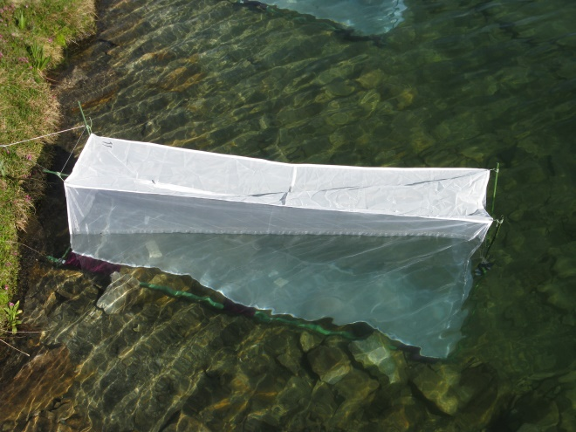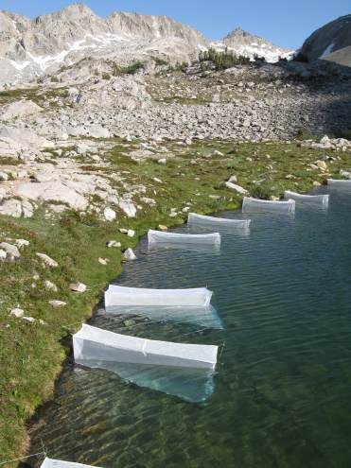

**A.**

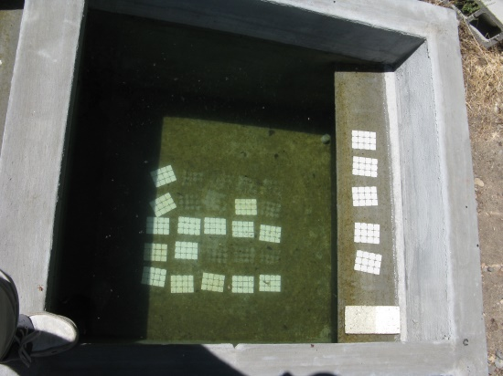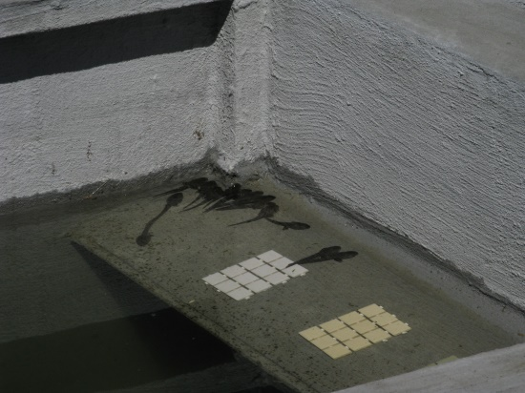

**B.**

FIG. 1. A) Field enclosures in LeConte lake in Kings Canyon National Park, and b) mesocosms located at Sierra Nevada Aquatic Research Laboratory in Mammoth Lakes, CA.

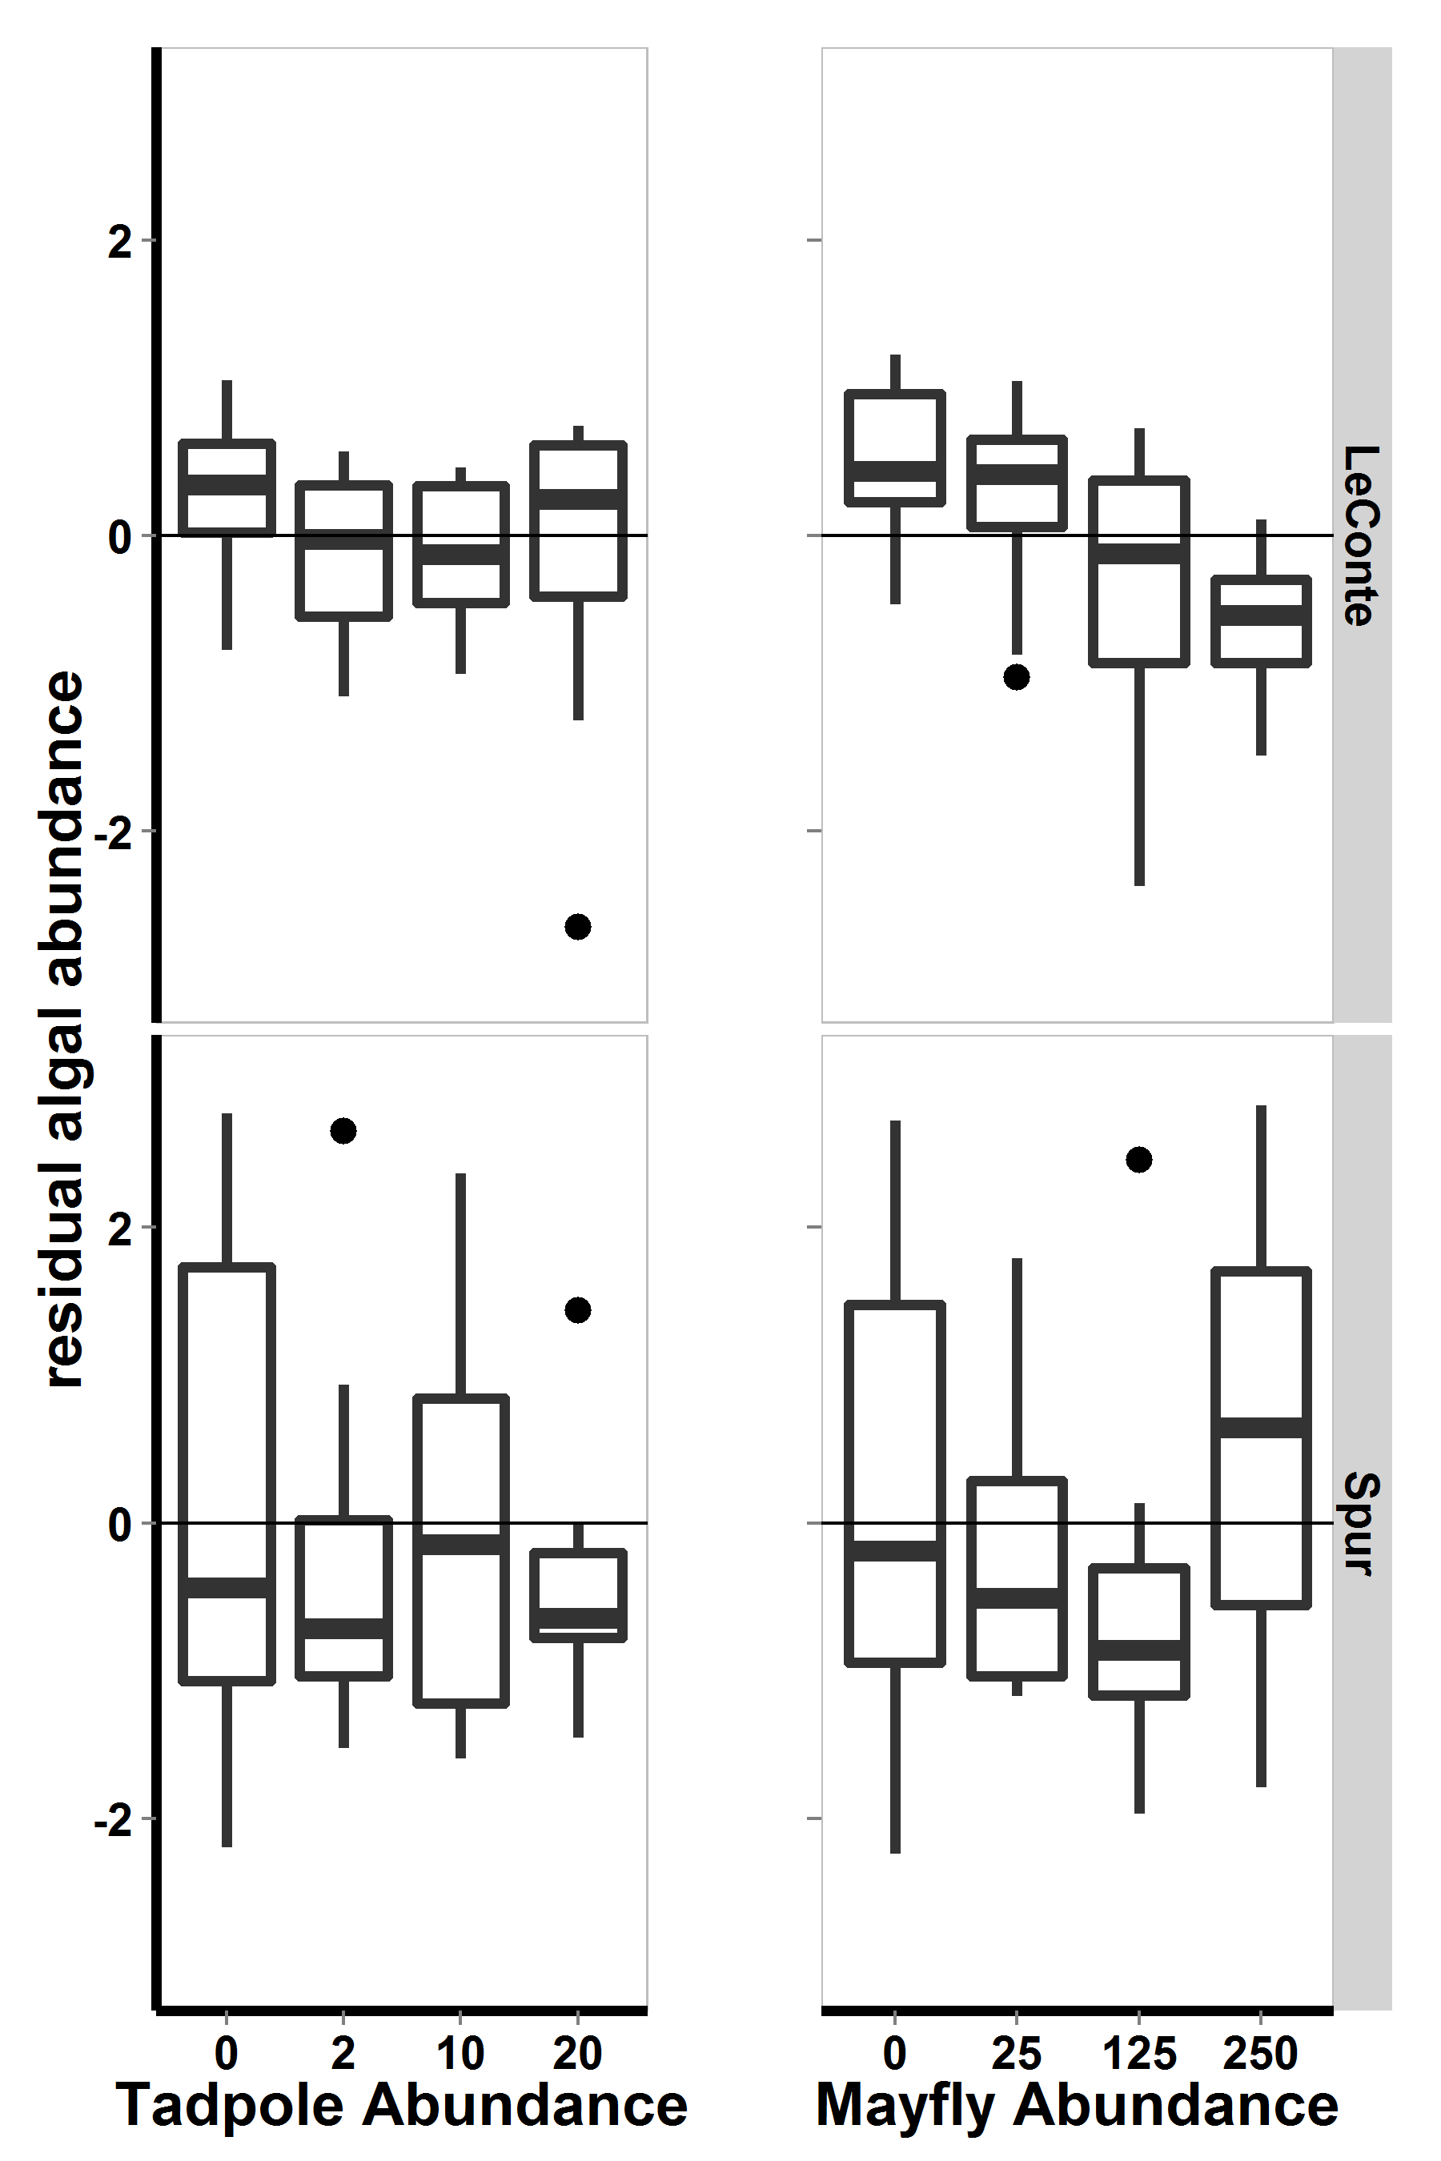

FIG 2. For 2009 field enclosure experiment, a) residuals of model including both consumers with respect to lake, b) residuals of model including lake and tadpole density with respect to mayfly density, and c) residuals of model including lake and mayfly density with respect to tadpole density. Bars show medians, boxes include 50% of the data, and whiskers include 95% of the data.

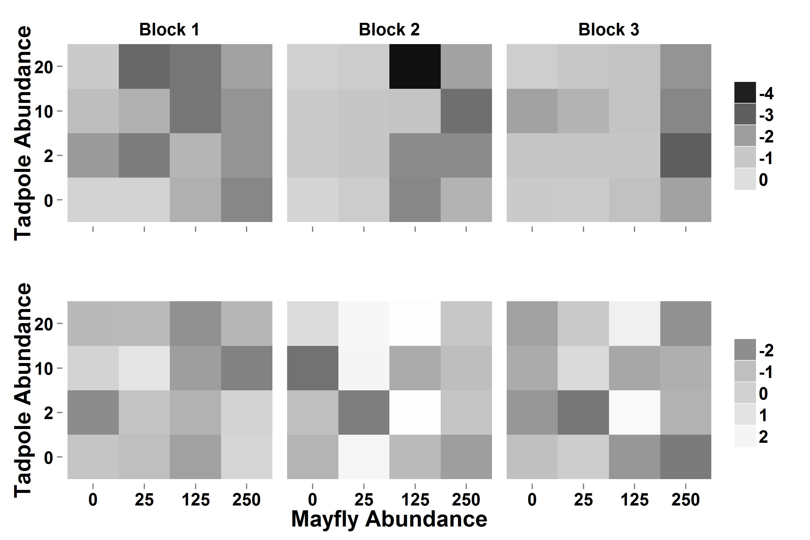

FIG 3. For 2009 field enclosure experiment, heat map displaying log-transformed algal abundance with respect to consumer densities, lake (top: LeConte, bottom: Spur), and experimental block. Darker colors indicate that algal abundance was low, while light colors indicate that algal abundance was high.

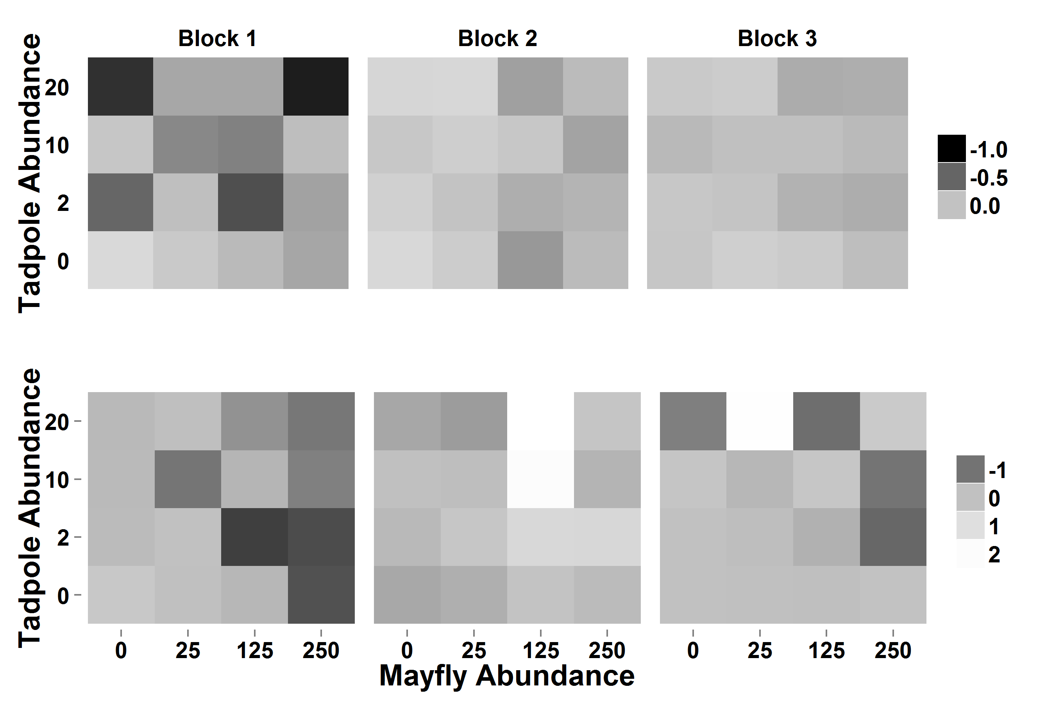

Fig 4. Heat maps showing algal abundance relative to pseudocontrols in experimental enclosure in LeConte (top) and Spur (bottom). For display purposes, the difference between algal abundance in pseudocontol and treatments was log-modulus transformed. Darker colors indicate that algal abundance was lower in the enclosure than in the control, medium gray indicates approximately no difference between controls and enclosures, while light colors indicate that algal abundance was high in enclosures relative to controls.



Figure – Probably not plotted, but currently serving as a placeholder. For field enclosures, estimated tadpole AFDM (mg, based on Gosner stage-AFDM regression) with respect to tadpole density in enclosures in LeConte (left panel) and in Spur (right panel). There was no effect of tadpole or mayfly density on tadpole size, stage, or AFDM.



FIG 5. Currently a place holder figure for one by which will be made by Yishen: For 2009 field enclosures, mayfly lengths (mm) with respect to tadpole density (for zero and twenty tadpoles only), to mayfly species, and to lake.

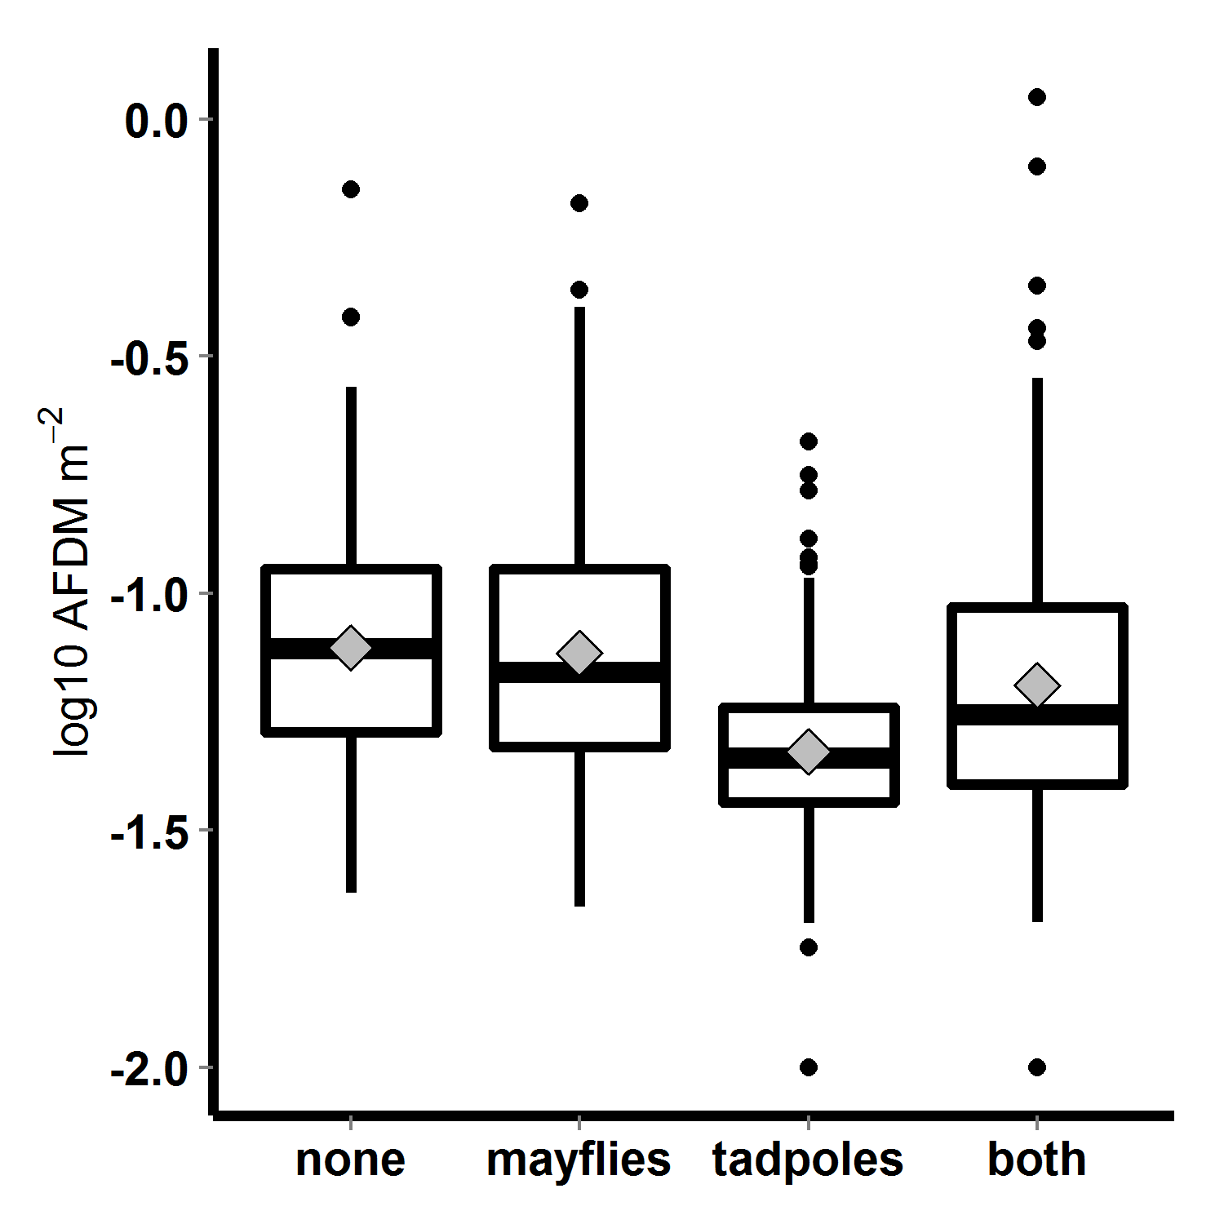

FIG 6. Algal abundance (log10 transformed AFDM) in 2010 mesocosms, with respect to tadpole and mayfly treatments; bars indicate medians, boxes contain 50% of data, whiskers contain 95% of the data, points are outliers, and diamonds indicate means.

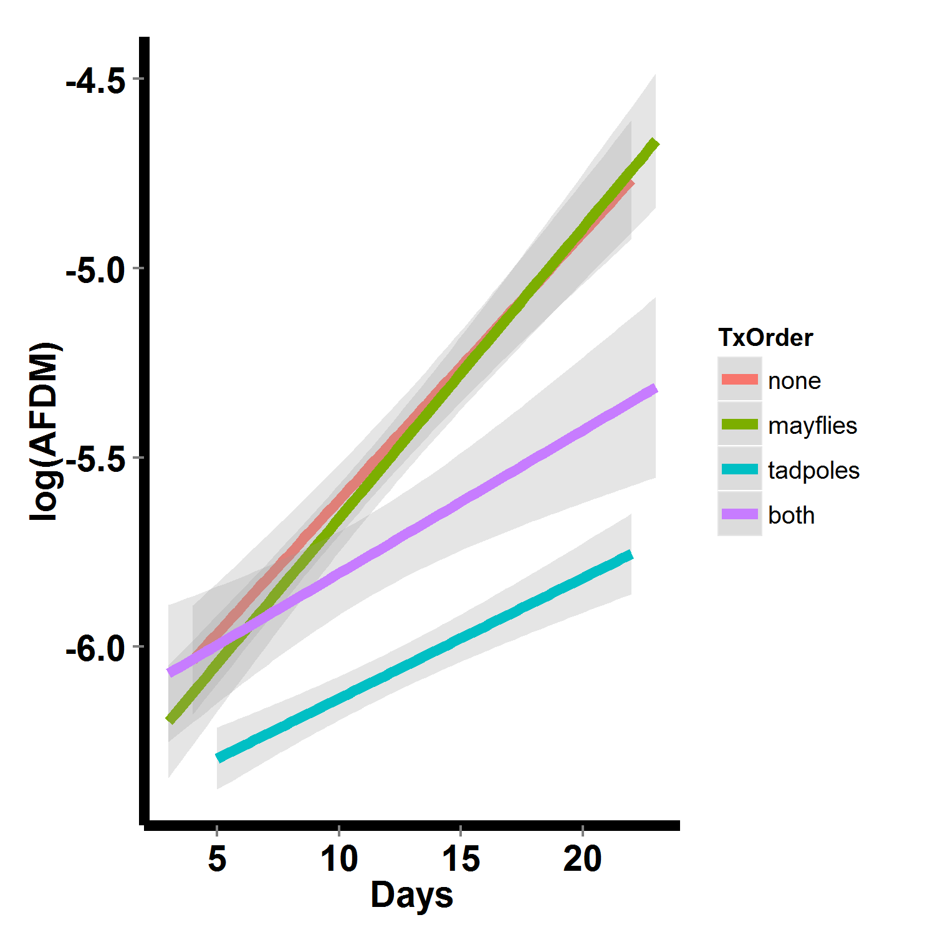

FIG 7. Algal abundance over time in 2010 mesocosms, with respect to consumer treatment. Lines are linear fits with standard error regions around them.